December 2019 Social Media Content Calendar
To add pictures to social media, right click on the image and select “save picture as” to save image on your computer. This restores correct sizing when uploading to social media.
Image |  |  | Facebook/Instagram | Twitter
Week of December ____________  (Census History)  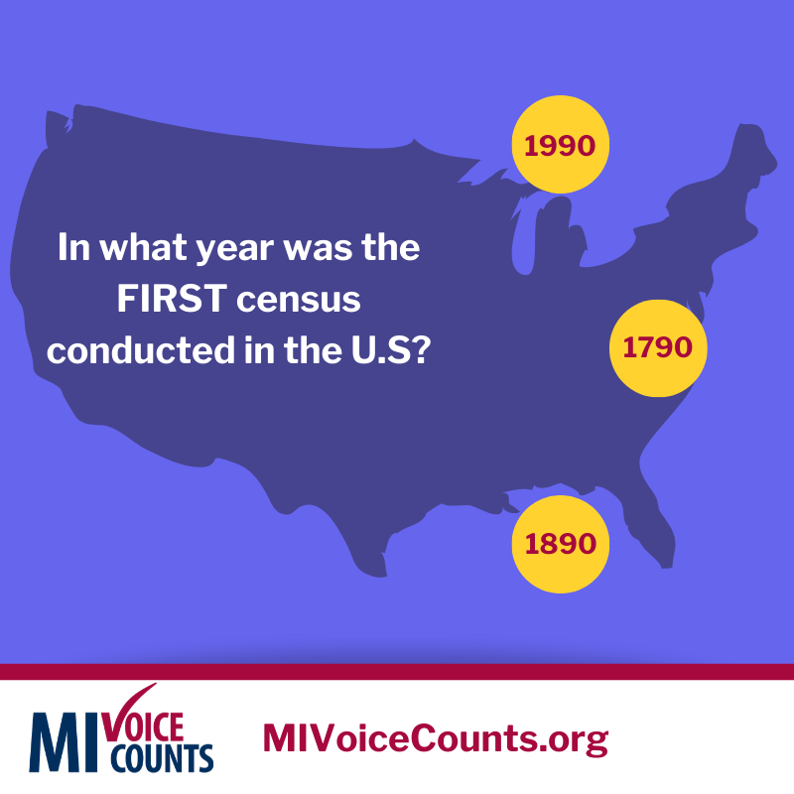 |  |  | Did you know the census has counted the U.S population every 10 years since 1790? This matters to our community because population numbers determine how much money Michigan receives to provide health and nutrition programs for children and seniors. Make your voice heard Spring 2020. Fill out the census. Everyone Counts. Everyone Wins.  www.MIVoiceCounts.org  #MIVoiceCounts #BeCountedMI2020 #2020Census #census2020 | The census has counted the U.S population every 10 years since 1790. These numbers determine how much money MI receives to provide health and nutrition programs for children and seniors. Fill out the census Spring 2020: www.MIVoiceCounts.org #MIVoiceCounts  #BeCountedMI2020 #2020Census #census2020
Week of December ______________  (Census data for children)  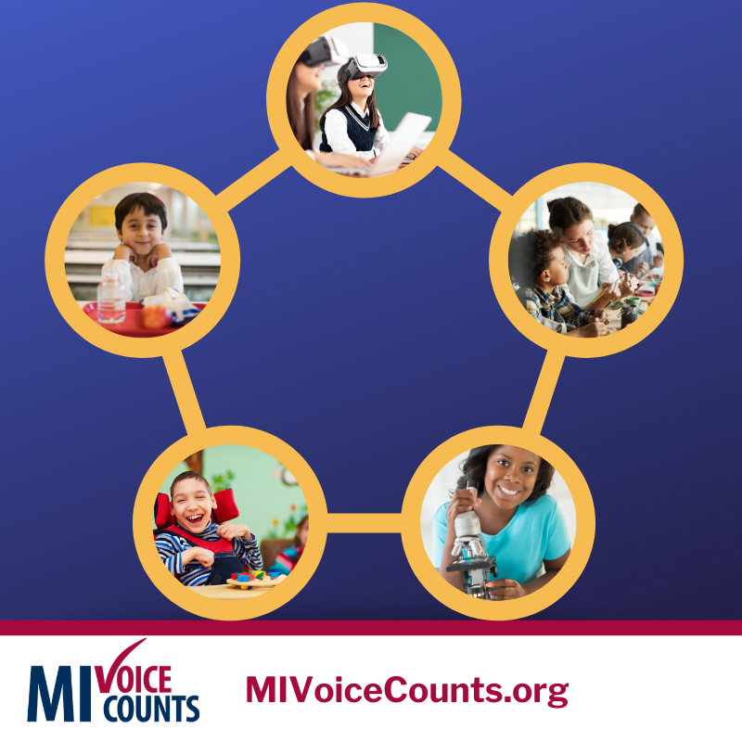 |  |  | Did you know that completing the census impacts the federal funds our community receives for special education, classroom technology, teacher training, after-school programs, school lunches, and more? Filling out the census in  Spring 2020 shows how much we care for our kids and community.  When Everyone Counts. Everyone Wins! Be counted: www.MIVoiceCounts.org #MIVoiceCounts #BeCountedMI2020 #2020Census #census2020  #michigankids | Did you know that completing the census impacts how much funding goes to programs at your children’s school? Fill out the census Spring 2020: www.MIVoiceCounts.org. #MIVoiceCounts #BeCountedMI2020 #2020Census #census2020  #michigankids
Week of December ______________  (Census data for senior health)  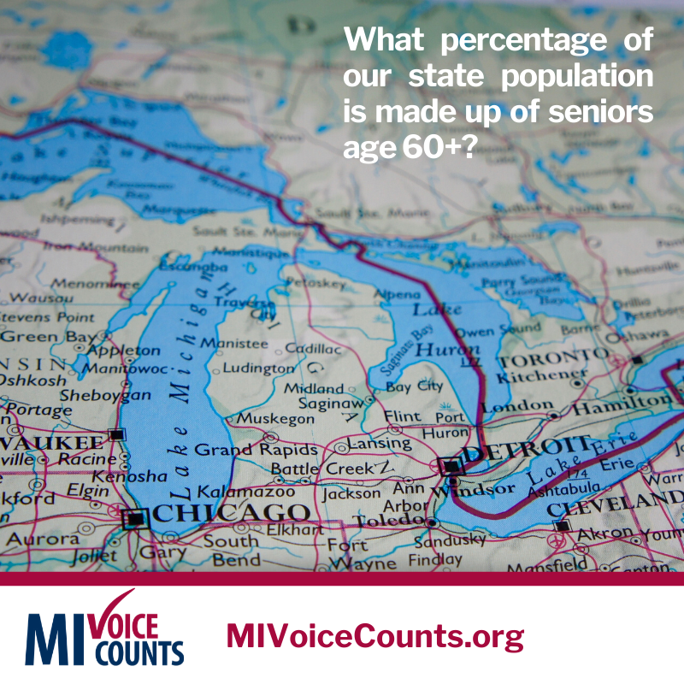 |  |  | Did you know that Michigan residents age 60 and older makeup 25% of our state's population?  Census data are used to fund medical programs that cover doctors’ visits, preventive services, and medical equipment. These programs improve the quality of life for seniors in our community. Make your voice count Spring 2020.  When Everyone Counts. Everyone Wins! Be counted: www.MIVoiceCounts.org#MIVoiceCounts #BeCountedMI2020 #2020Census #census2020 #seniorcitizens #elderlycare | Did you know Michigan residents 60 and older makeup 25% of our states population? Census data are used to fund critical services and programs that improve quality of life for seniors. Be counted: www.MIVoiceCounts.org #MIVoiceCounts #BeCountedMI2020  #seniorcitizens #elderlycare
Week of December ______________  (Confidentiality)  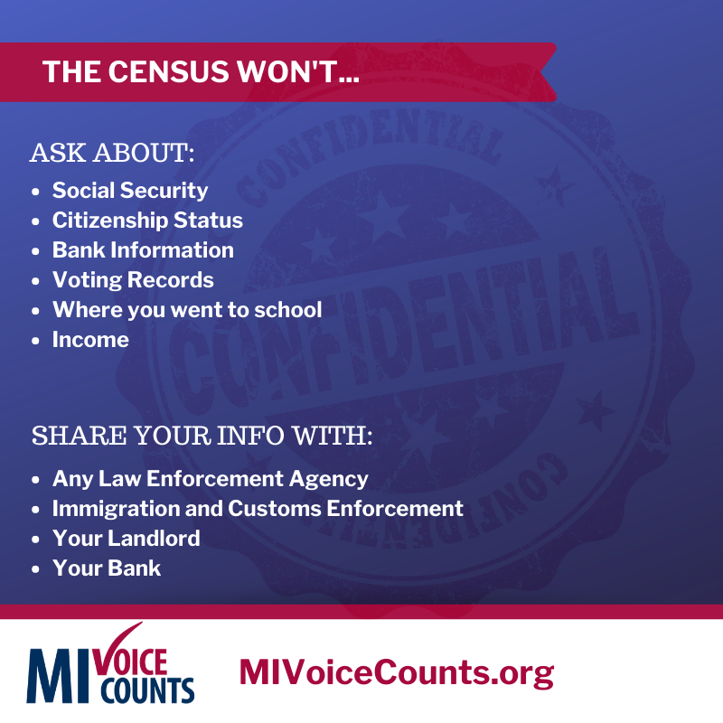 |  |  | Did you know the census is confidential?  The census will NOT ask for your:  - Social Security Info  - Banking Information  - Citizenship Status  - Income  - Voting Records  It’s the law that your census information cannot and will not be shared with ANY agency. Check out the nine census questions here: www.MIVoiceCounts.org  #MIVoiceCounts #BeCountedMI2020 #2020Census #census2020 #privacy | Not sure about filling out the #census? Worried about your personal information? It’s the law that your personal census information cannot and will not be shared with ANY agency. Check out the nine census questions here: www.MIVoiceCounts.org  #BeCountedMI2020 #MIVoiceCounts
Week of December ______________  (Census impact) 9-10-10  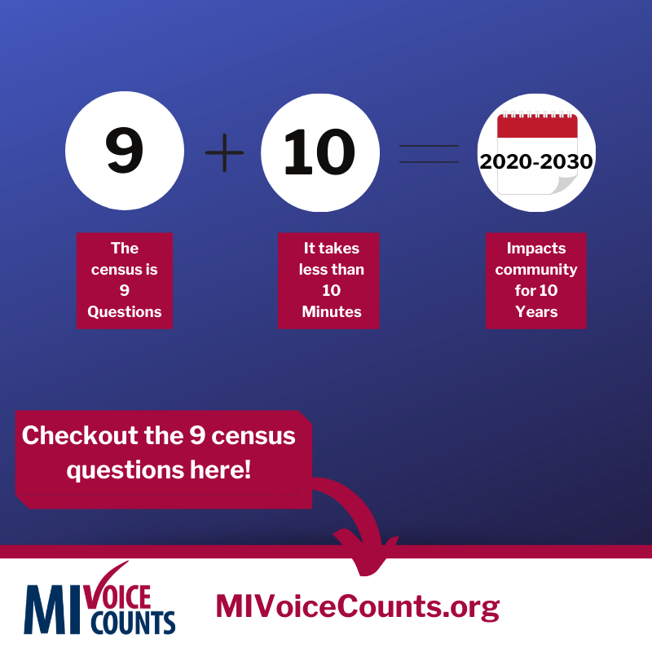 |  |  | Did you know the census is only 9 questions?  That’s right, 9 questions. It takes less than 10 minutes to complete and impacts our community for 10 years.  Everyone who fills out the census helps make a true difference in the lives of our neighbors, friends, and family. Census data affect things like public libraries, school lunch programs, and health services. Check out the 9 questions here: www.MIVoiceCounts.org  #MIVoiceCounts #BeCountedMI2020 #2020Census #census2020 | Did you know the census is only 9 questions?  That’s right, 9 questions. It takes less than 10 minutes to complete and impacts our community for 10 years.  Check out the 9 questions here: www.MIVoiceCounts.org  #MIVoiceCounts #BeCountedMI2020 #2020Census #census2020
Week of December _____________  (Education) Pell Grants   |  |  | Did you know census data help students pay for college? Funds for Federal Pell Grants are distributed using census data. Pell Grants, unlike loans, do not need to be repaid. They help students in our community access a college education. Fill out the census Spring 2020. www.MIVoiceCounts.org  #MIVoiceCounts #BeCountedMI2020 #2020Census #census2020 #pellgrant #highereducation | Did you know census data helps students pay for college? Funds for Federal Pell Grants are distributed using census data and do not need to be repaid. Fill out the census Spring 2020. www.MIVoiceCounts.org  #MIVoiceCounts #BeCountedMI2020 #2020Census #census2020 #pellgrant #highereducation
Week of December _____________

(Holiday Message)

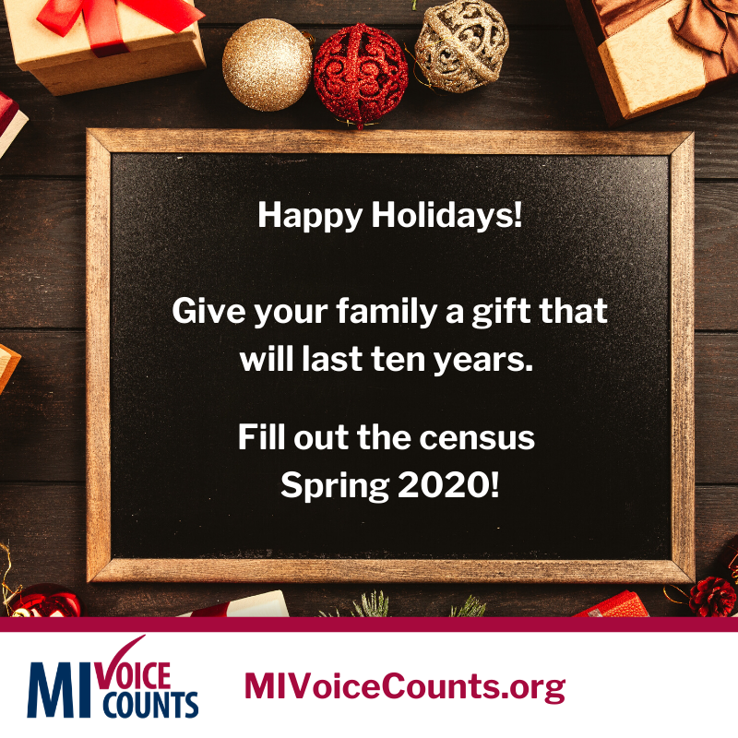
 |  | Blank Template  Add your own image to this template and get social! |  | 
hel

