November 2019 Social Media Content Calendar
Image |  |  | Facebook/Instagram | Twitter
Election Day November 5th  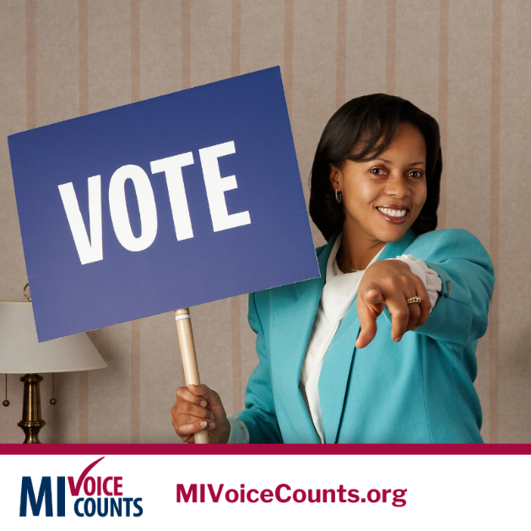 |  |  | Election Day is a good reminder that not only does your vote count, it’s also really important to be counted. Make sure you complete the 2020 Census in the Spring of 2020. The way the government spends your tax dollars, the way businesses make decisions, and the way we elect our leaders all depend on it! The 2020 population numbers will shape how political power and federal tax dollars are shared in the U.S over the next 10 years.  When Everyone Counts. Everyone Wins! Be counted: www.MIVoiceCounts.org. #ElectionDay2019 #MIVoiceCounts #BeCountedMI2020 #2020Census #census2020 | #ElectionDay is a good reminder that not only does your vote count, it’s also really important to be counted! Make sure you complete the #2020Census in the Spring. Population numbers shape how political power & federal tax dollars are shared in US over next 10 years: www.MIVoiceCounts.org #MIVoiceCounts
Week of November 4th  (Census data at work in the community)  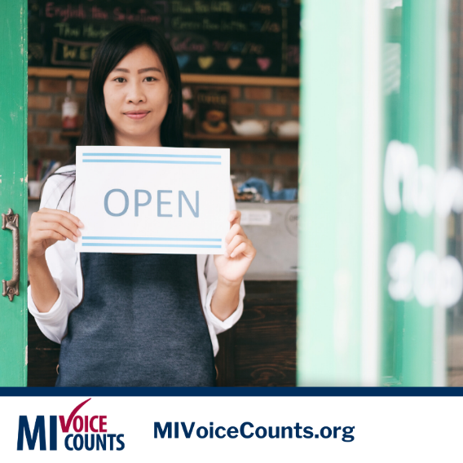 |  |  | Guess how businesses decide where to put a new store, office, or plant? They use census data!  These new businesses help create jobs and support our community’s economy. Census data is collected every 10 years. Make your voice count for your community in 2020. When Everyone Counts. Everyone Wins! Be counted: www.MIVoiceCounts.org. #MIVoiceCounts #BeCountedMI2020 #2020Census #census2020  #shoplocalmichigan | Guess how businesses decide where to put a new store or office? Census data!  These new businesses help support our community’s economy. Your voice counts for your community in 2020. Visit: www.MIVoiceCounts.org. #MIVoiceCounts #BeCountedMI2020 #2020Census  #shoplocalmichigan
Veteran’s Day November 11th   |  |  | Honor the veteran in your life by making sure they are counted in the #2020Census. Data about veterans help plan and fund government programs that provide veterans with critical services and programs. When Everyone Counts. Everyone Wins! Be counted: www.MIVoiceCounts.org. #ElectionDay2019 #MIVoiceCounts #BeCountedMI2020 #2020Census #census2020 #veteransday2019 | This #Veteransday2019 honor them by making sure they are counted in the #2020Census. Data is used to fund critical services and programs for veterans. Be counted: www.MIVoiceCounts.org #MIVoiceCounts #BeCountedMI2020
Week of November 11th  (Confidentiality)  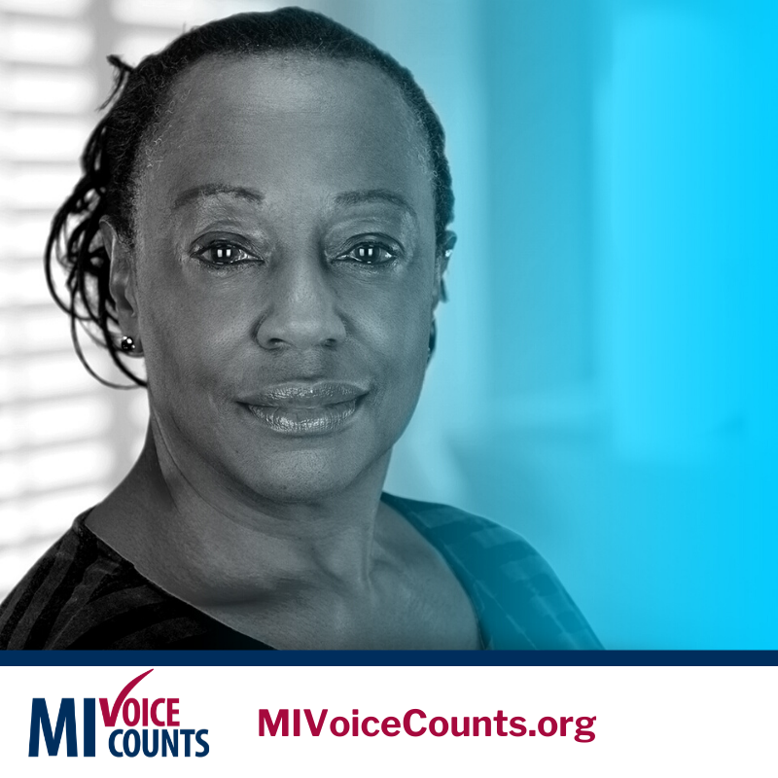 |  |  | Not sure about filling out the census? Worried about your personal information? Don’t let rumors, misunderstandings, or misinformation prevent you from getting access to the valuable programs you need to help you, your family, and community. It’s the law that your personal census information cannot and will not be shared with ANY agency. Curious about the nine census questions? Check them out here: www.MIVoiceCounts.org  #MIVoiceCounts #BeCountedMI2020 #2020Census #census2020 | Not sure about filling out the #census? Worried about your personal information? It’s the law that your personal census information cannot and will not be shared with ANY agency. Check out the nine census questions here: www.MIVoiceCounts.org  #BeCountedMI2020 #MIVoiceCounts
Week of November 18th  (Census data at work in the community)  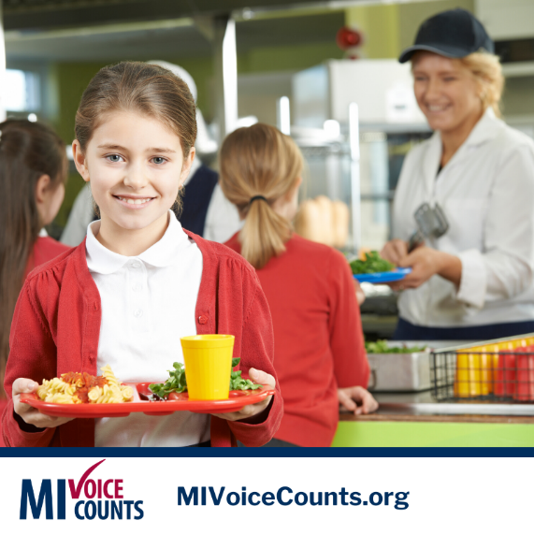 |  |  | Everyone Counts. Everyone Wins! It’s more than a tag line. Everyone who fills out the census in our community helps to make a true difference in the lives of our neighbors, friends, and family. Census data affects things like public libraries, school lunch programs, and health services. Learn more about the census in your community by visiting: www.MIVoiceCounts.org  #MIVoiceCounts #BeCountedMI2020 #2020Census #census2020 | Everyone who fills out the census in our community helps to make a true difference in the lives of our neighbors, friends, and family. Learn more about the census in your community by visiting: www.MIVoiceCounts.org  #MIVoiceCounts #BeCountedMI2020 #2020Census #census2020
Week of November 25th  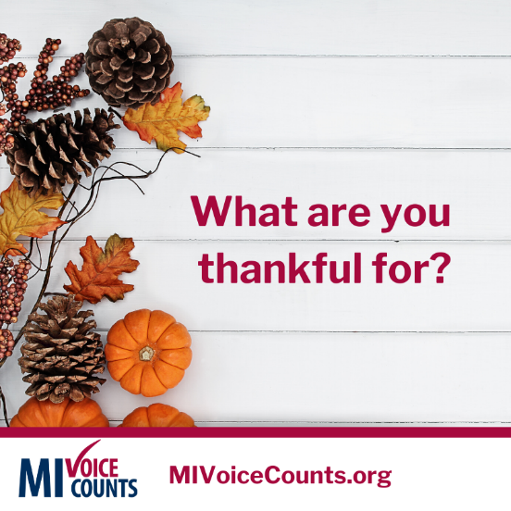 |  |  | We’re thankful for the opportunity to make a difference in our community. One way to make a difference is being counted in the 2020 Census. It affects our voice in government, and funding for things like schools and hospitals. Learn more about how census data impacts you and your community. Visit www.MIVoiceCounts.org  #MIVoiceCounts #BeCountedMI2020 #2020Census #census2020 #thanksgiving2019 | We’re thankful for the opportunity to make a difference in our community. Learn how census data impacts you and your community. Visit www.MIVoiceCounts.org  #MIVoiceCounts #BeCountedMI2020 #2020Census #census2020 #thanksgiving2019
Small Business Saturday  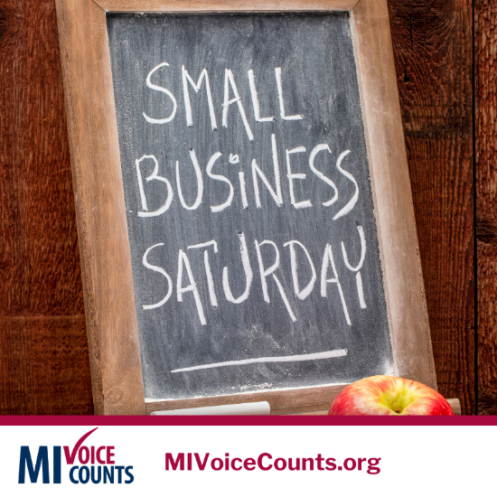 |  |  | Got a business idea? Great! Not sure where to locate it? Census data can help you make informed decisions on where you should set up shop and how to market to your potential customers. Learn more about why it’s important to be counted in the 2020 Census here: www.MIVoiceCounts.org  #MIVoiceCounts #BeCountedMI2020 #2020Census #census2020 #shopsmall #smallbusinesssaturday | Got a business idea? Great! Not sure where to locate it? Census data can help you decide where to set up shop & how to market to potential customers. More on the #2020Census here: www.MIVoiceCounts.org  #MIVoiceCounts #BeCountedMI2020 #2020Census #shopsmall #smallbusinesssaturday
 |  | Blank Template  Add your own image to this template and get social! |  | 